Optional file marea_transit_fuel.csv
May 21, 2026
Definition of the Input File
VisionEval (https://visioneval.github.io/docs/model-inputs.html) explains that this optional file gives the transit fuel proportions for non-electric vehicles. The user does not have to include this file—it is only needed if the user wants to modify the transit fuels proportions. The first six attributes show, for vans and buses respectively, the proportion of non-electric vehicles fueled by diesel, gasoline, or compressed natural gas (CNG). The last two attributes show the proportion of non-electric rail fueled by diesel or gasoline.
For example, the input file below indicates that either Albemarle County has no bus, van, or rail service or if it does have such service, the defaults for bus, van, and rail (non-electric) fuels should be used. For Charlottesville city, all non-electric vans use diesel fuel and all non-electric buses use diesel fuel. For Charlottesville city, there either is no rail travel or the non-electric rail should use the defaults.
Note that unlike Azones or Bzones, there should be just a single Marea file when running VisionEval. For instance, consider the Charlottesville-Albemarle MPO. There will be just one Marea file. When combining these files, note that VisionEval will crash if there is a mix of numbers and NA within any of the three groups above. For example, options 1 and 2 are fine, but option 3 shown below will cause a crash.
Option 1. Each group has NA values only (this will work)

Option 2. Some groups have all NA values and others have all numbers (this will work)

Option 3. A single group has a mix of NA values and numbers (this will fail)
Note that a blank cell will perform the same as an NA value.
Possible Scenario
The main reason for using this file appears to be not to develop scenarios but rather to better quantify the impacts of certain changes—e.g., there may be a difference in terms of emissions between electrification of a fleet that runs on diesel versus electrification of a fleet that runs on gasoline. The document Task 7.2 Simplified Scenario Development guide available at A Playbook for Simplified Approaches for Creating Scenarios in VisionEval mentions this input file but does not describe it further, except to say that it is optional.
Method Used for Virginia
Although the extrapolation method below gives 2024 and 2045 values, the research team believes that the short-term extrapoloation (to 2024) is reliable but the 2045 extrapoloation is speculative. Thus, the 2045 values are set to be equal to the 2024 values.
Three major categories of steps were used to develop these data for the 2024 base year.
- Source: 2023 Annual Database Revenue Vehicle Inventory, National Transit Database (NTD)
  - URL: https://www.transit.dot.gov/ntd/ntd-data
  - Location: NTD Data–NTD Data Reports
  - Search Keyword: Revenue
  - Related Sheet: 2023 Revenue Vehicle Inventory

- Year that the Data Reflect: 2024 (The 2024 value was projected using data from 2021 to 2023.)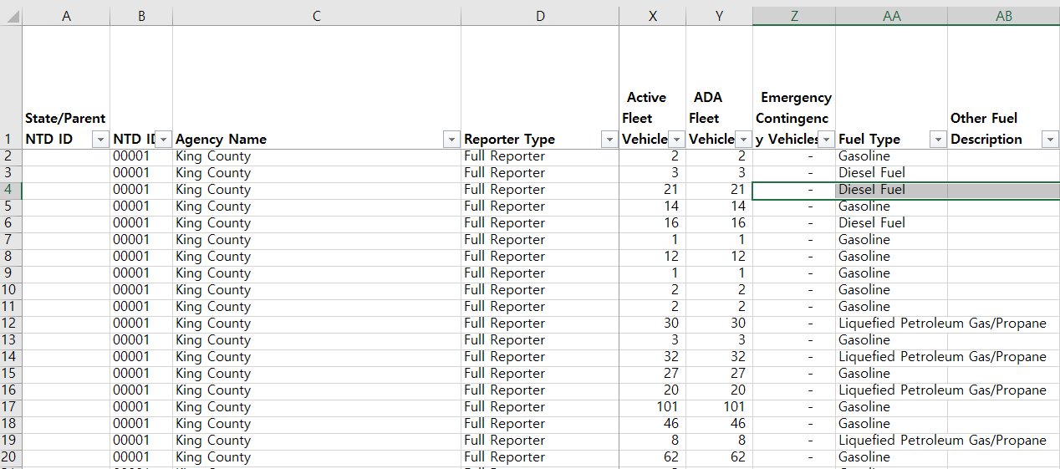

- How the Data Were Processed
  - Fuel Type Mapping: In VisionEval, fuel types must be entered as one of three categories: Gasoline, Diesel, or CNG. Accordingly, the original fuel types were mapped to these three categories as shown below.
Fuel Type (NTD) | Category
Diesel Fuel | Diesel
Hybrid Diesel | Diesel
Diesel Fuel/Electric Propulsion Power | Diesel
Diesel Fuel/Liquefied Petroleum Gas/Propane | Diesel
Gasoline | Gasoline
Hybrid Gasoline | Gasoline
Gasoline/Ethanol | Gasoline
Gasoline/Compressed Natural Gas | Gasoline
Gasoline/Liquefied Petroleum Gas/Propane | Gasoline
Hybrid Gasoline/Liquefied Petroleum Gas/Propane | Gasoline
Compressed Natural Gas | CNG
Liquefied Natural Gas | Excluded
Bunker Fuel | Excluded
Electric Battery | Excluded
Electric Propulsion Power | Excluded
Ethanol | Excluded
Hydrogen | Excluded
Liquefied Petroleum Gas/Propane | Excluded
Other | Excluded
Blank | The same fuel type was applied to vehicles of the same mode operated by the same agency.
  - Vehicle Type Mapping: The vehicle types provided by the NTD were mapped to the VisionEval input format as summarized below.
Vehicle Type (NTD) | Category
Articulated Bus | Bus
Bus | Bus
Double Decker Bus | Bus
Over-the-road Bus | Bus
School Bus | Bus
Trolleybus | Bus
Ferryboat | Excluded
Other | Excluded
Aerial Tramway | Excluded
Cable Car | Excluded
Commuter Rail Locomotive | Rail
Commuter Rail Self-Propelled Passenger Car | Rail
Light Rail Vehicle | Rail
Automated Guideway Vehicle | Rail
Heavy Rail Passenger Car | Rail
Inclined Plane Vehicle | Rail
Monorail Vehicle | Rail
Vintage Trolley | Rail
Commuter Rail Passenger Coach | Rail
Automobile | Van
Cutaway | Van
Minivan | Van
Sports Utility Vehicle | Van
Van | Van

  - Use of NTD IDs for Filtering: Unlike the 2023 TS2.1 Service Data and Operating Expenses Time Series by Mode, the 2023 Annual Database Revenue Vehicle Inventory does not include a field that allows for direct filtering by Virginia. Therefore, NTD IDs corresponding to Virginia agencies—identified in the TS2.1 dataset—were used for filtering, as shown below.
NTD ID | Agency Name | City | State
30006 | Greater Richmond Transit Company (GRTC) | Richmond | VA
30007 | Greater Roanoke Transit Company (GRTC) | Roanoke | VA
30008 | Greater Lynchburg Transit Company (GLTC) | Lynchburg | VA
30009 | City of Petersburg (PAT) | Petersburg | VA
30036 | City of Charlottesville (CAT) - Transit | Charlottesville | VA
30045 | JAUNT, Inc. | Charlottesville | VA
30053 | City of Bristol Virginia (BVT) - Transit Department | Bristol | VA
30058 | City of Fairfax (CUE) - Transportation Division in the Public Works Department | Fairfax | VA
30068 | Fairfax County, VA - Transportation | Fairfax | VA
30069 | City of Danville - Mass Transit | Danville | VA
30070 | Potomac and Rappahannock Transportation Commission (PRTC) | Woodbridge | VA
30071 | City of Alexandria - Department of Transportation and Environmental Services/Transportation Branch | Alexandria | VA
30073 | Virginia Railway Express (VRE) | Alexandria | VA
30076 | Williamsburg Area Transit Authority (WATA) | Williamsburg | VA
30079 | City of Fredericksburg (FRED) - Transit Department | Fredericksburg | VA
30080 | Arlington County, Virginia (ART) - Department of Environmental Services | Arlington | VA
30081 | Loudoun County - Transit Division - Department of General Services | Leesburg | VA
30083 | Transportation District Commission of Hampton Roads (HRT) | Hampton | VA
30091 | Town of Blacksburg (BT) - Transit | Blacksburg | VA
30094 | City of Harrisonburg (HDPT) - Department of Public Transportation | Harrisonburg | VA
30099 | City of Winchester - Winchester Transit | Winchester | VA
30114 | Accomack-Northampton Transportation District Comm - Public Transportation | Tasley | VA
30115 | New River Valley Senior Services, Inc. (PAT) - Public Transportation | Radford | VA
30118 | Virginia Regional Transit (VRT) | Purcellville | VA
30123 | District Three Governmental Cooperative | Marion | VA
30132 | Mountain Empire Older Citizens - Transit | Big Stone Gap | VA
30142 | Lake Country Area Agency on Aging - Transportation | South Hill | VA
30157 | Town of Altavista (ACTS) - Transportation | Altavista | VA
30164 | Town of Bluefield - Transit | Bluefield | VA
30165 | Town of Farmville (FAB) | Farmville | VA
30172 | Bay Aging - Public Transportation | Urbanna | VA
30174 | Appalachian Agency for Senior Citizens - Public Transit | Cedar Bluff | VA
30178 | Unified Human Services Transportation Systems, Inc (RADAR ) | Roanoke | VA
30184 | Town of Blackstone (BABS) | Blackstone | VA
30198 | City of Suffolk - Public Works | Suffolk | VA
30200 | City of Radford - Transportation | Radford | VA
30203 | York County - Tourism | Yorktown | VA
30204 | Colonial Williamsburg Foundation (CWF) | Williamsburg | VA
30989 | Central Shenandoah Planning District Commission (CSPDC) | Staunton | VA
31025 | County of Greensville (GET) - Transportation | Emporia | VA

  - Aggregation Using Excel: The 2021-2023 data were aggregated using the sumifs function in Excel, as summarized in the table below. 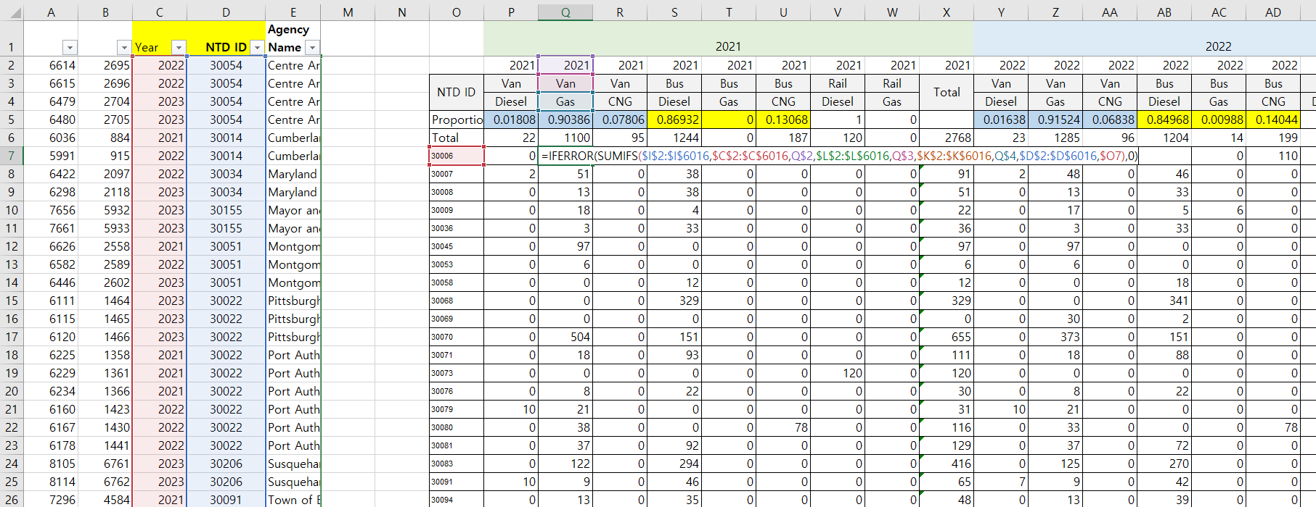

  - Base Year and Target Year Values Projection: The 2024 base year values were projected using the compound annual growth rate (CAGR) calculated from 2021 to 2023. For the target year, instead of applying individual growth rates, a generalized total growth rate was used across all categories. 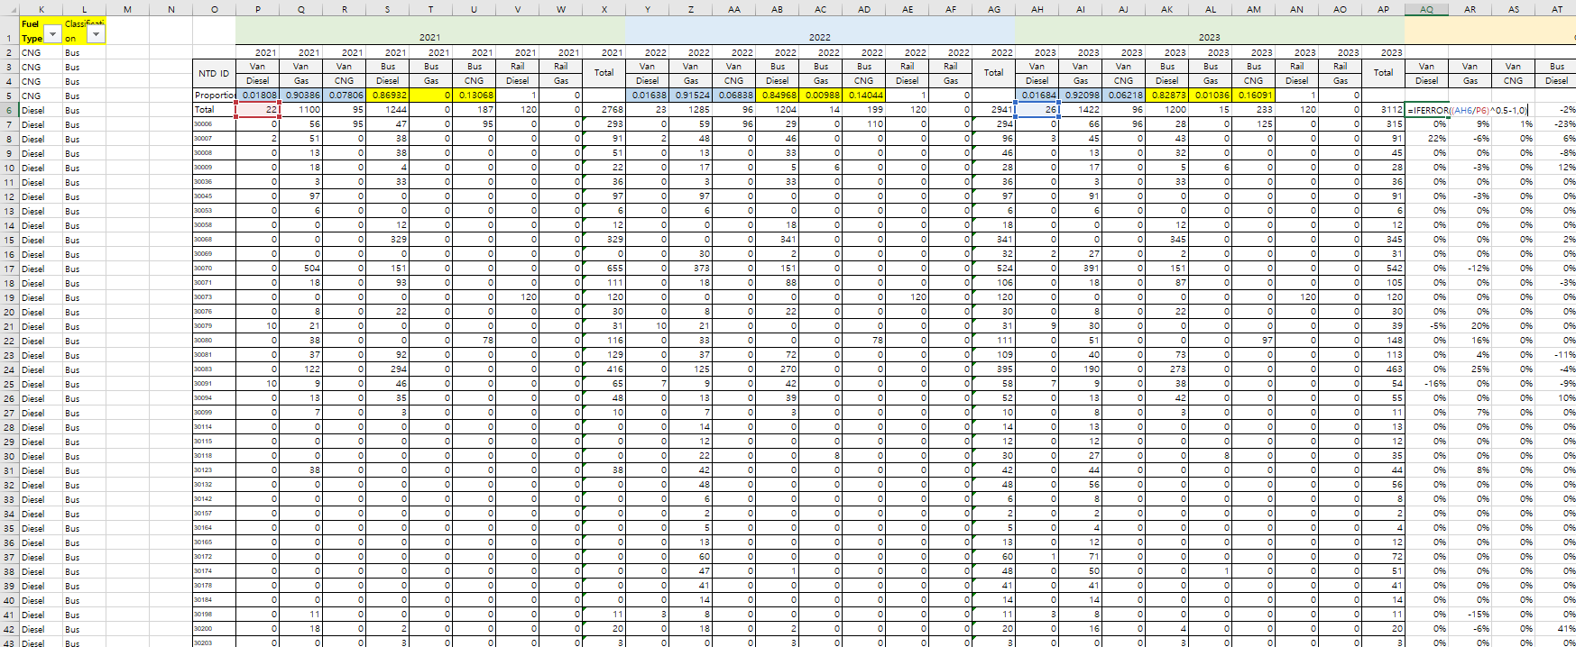 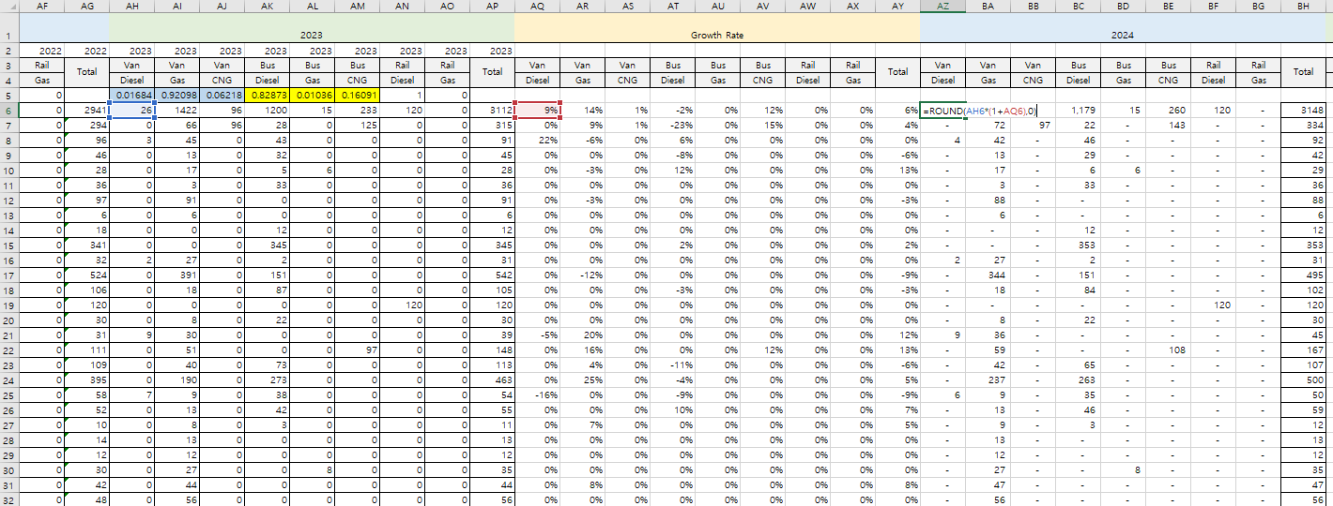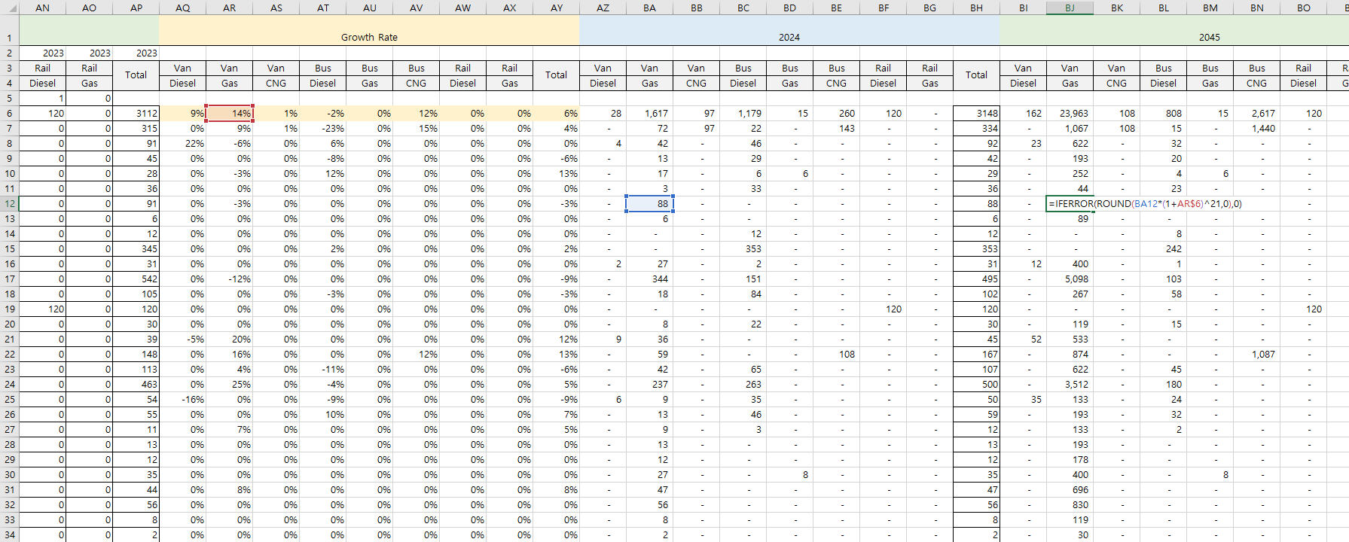

  - Classification Based on Marea Geography: To ensure consistency with the geographic structure used in other marea_* input files, the data were reorganized as shown below. 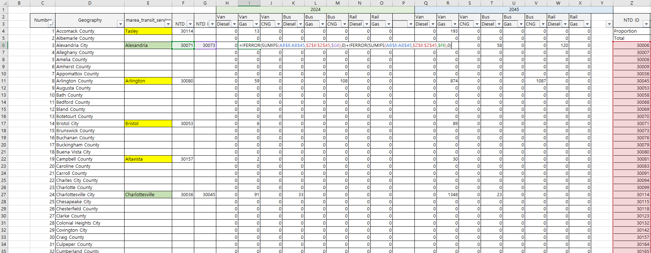

Note: Some cities, such as Charlottesville, are associated with more than one NTD ID. Care should be taken to avoid double counting when aggregating data.

  - Ratio Calculation and Final Result: Final input values were calculated based on the derived ratios and aggregated data.

Note: To prevent the VisionEval crashes, specific vehicle type does not exist within a county or city, the value in the input files should be entered as NA instead of 0.
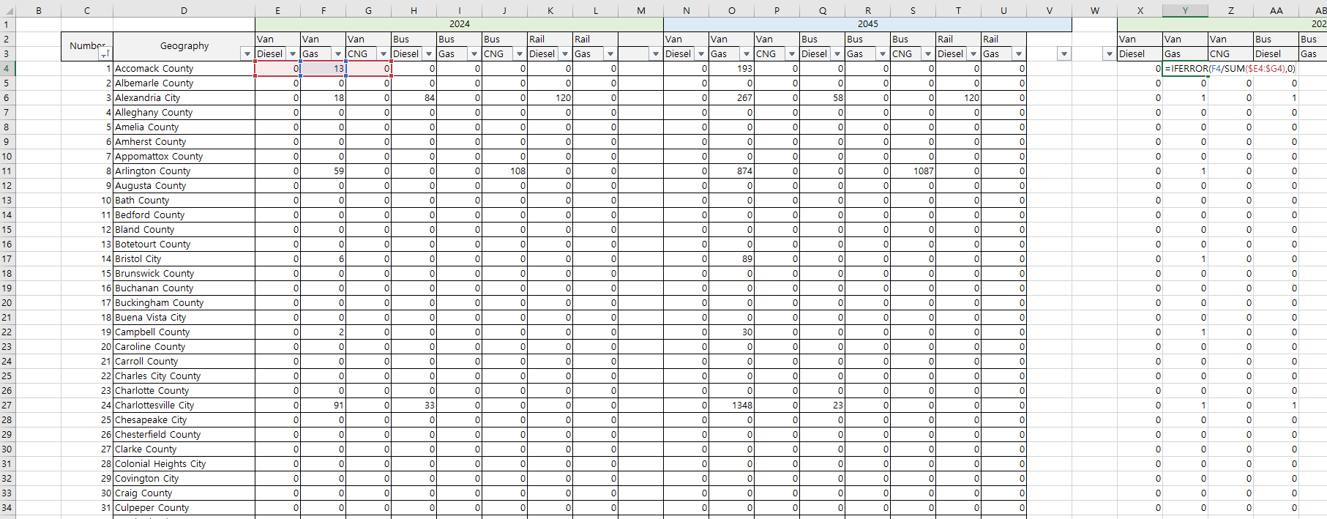
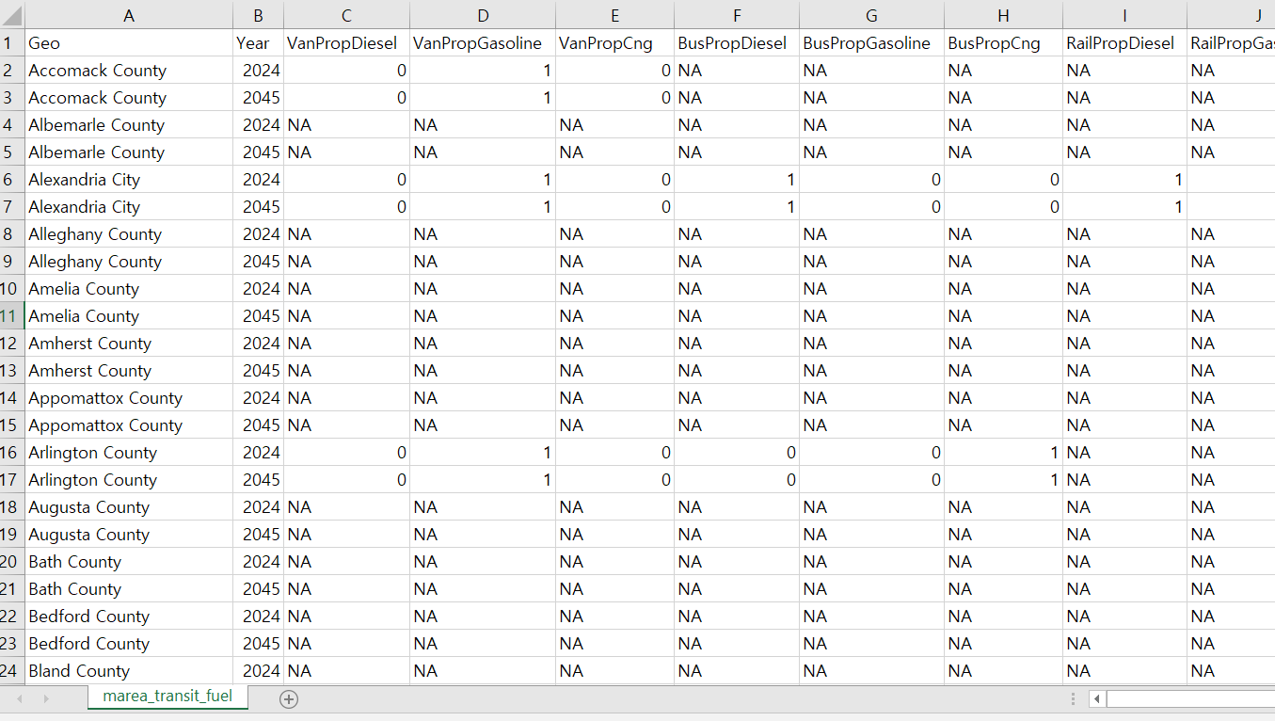

Appendix A. NTD Modes Explanation
Mode Code | Meaning | Mode Code | Meaning
DR/PT | Demand Response / Public Transit | TR/PT | Aerial Tramway / PT
DR/TX | Demand Response / Taxi | CB/DO, DR/DO | Mixed bus and paratransit
FB/DO | Ferryboat / Direct Operation | CB/DO, DR/DO, MB/DO | Mixed across 3 bus types
MB/DO | Motorbus / Direct Operation | CB/PT, DR/PT | Contracted commuter + DR
MB/PT | Motorbus / Purchased Transportation | CB/PT, DR/PT, MB/PT | 3 contracted modes
SR/DO | Streetcar / Direct Operation | CB/PT, MB/PT | Commuter + Motorbus contracted
TB/DO | Trolleybus / DO | HR/DO | Heavy Rail / DO
VP/DO | Vanpool / DO | DR/DO, DR/PT, MB/DO | Mixed direct DR and MB
DR/DO | Demand Response / DO | MB/DO, RB/DO | Motorbus + Rapid Bus
CB/PT | Commuter Bus / PT | CR/DO | Commuter Rail / DO
RB/DO | Rapid Bus / DO | LR/PT | Light Rail / PT
VP/PT | Vanpool / PT | IP/DO | Inclined Plane / DO
DR/TN | Demand Response / TNC | MB/DO, MB/PT | Mixed Motorbus (DO & PT)
LR/DO | Light Rail / DO | MG/DO | Monorail / DO
YR/PT | Hybrid Rail / PT | HR/PT | Heavy Rail / PT
CB/DO | Commuter Bus / DO | PB/PT | Publico / PT
DR/DO, DR/PT | Mixed Demand Response | DR/DO, VP/DO | DR + Vanpool
DR/PT, MB/PT | Mixed DR and MB contracted | CR/DO, CR/PT | Mixed commuter rail (DO & PT)
CB/DO, MB/DO | Mixed commuter and city bus | DR/PT, DR/TX | DR public + taxi mix
DR/PT, VP/DO | Paratransit + Vanpool | TR/DO | Aerial Tramway / DO
DR/DO, MB/DO | DR + Bus (mixed direct) | CB/DO, RB/DO | Commuter + Rapid bus
MG/PT | Monorail / PT | YR/DO | Hybrid Rail / DO
FB/PT | Ferryboat / PT | CC/DO | Cable Car / DO
CR/PT | Commuter Rail / PT | CB/DO, CB/PT | Mixed commuter bus
AR/DO | Alaska Railroad / DO | DR/PT, MB/DO | DR and MB mixed
SR/PT | Streetcar / PT | DR/DO, MB/PT | DR and MB mixed contracted

Appendix B. NTD Vehicle Type Explanation
Vehicle Type | Description
Cutaway | Small- to mid-size buses with bus body on van/truck chassis. Often used for paratransit.
Van | Standard passenger vans used for DR or vanpool
Minivan | Smaller van, used in paratransit or small vanpool
Automobile | Standard cars (sedans, small cars) used in DR/TNC services
Ferryboat | Passenger watercraft
Articulated Bus | Extra-long bus with a flexible midsection
Bus | Standard transit bus
Light Rail Vehicle | Electric railcar operating on light rail tracks
Trolleybus | Bus powered by overhead wires
Sports Utility Vehicle (SUV) | SUV used for DR, TNC, or agency fleet
Over-the-road Bus | Long-distance coach bus (e.g., Greyhound-style)
Commuter Rail Self-Propelled Passenger Car | EMU/DMU-type cars that operate independently
Commuter Rail Passenger Coach | Unpowered passenger cars pulled by locomotive
Monorail Vehicle | Specialized vehicle on a monorail track
Double Decker Bus | Bus with two levels, used for city or commuter routes
Commuter Rail Locomotive | Engine that pulls commuter rail coaches
Aerial Tramway | Gondola or cable-suspended vehicle
Other | Nonstandard or unclassified vehicle
School Bus | School-style buses used in limited transit
Heavy Rail Passenger Car | Subway/metro car
Vintage Trolley | Historical replica trolley/streetcar
Inclined Plane Vehicle | Funicular on steep grades (e.g., Pittsburgh)
Automated Guideway Vehicle | Driverless rail vehicle, often rubber-tired
Cable Car | Powered by underground cable (e.g., SF cable car)

Appendix C. Vehicle Counts by Geography in Virginia
Number | Geography | marea_transit_service | NTD ID | Van |  |  | Bus |  |  | Rail
 |  |  |  | Diesel | Gas | CNG | Diesel | Gas | CNG | Diesel | Gas
1 | Accomack County | Tasley | 30114 | 0 | 13 | 0 | 0 | 0 | 0 | 0 | 0
2 | Albemarle County
3 | Alleghany County
4 | Amelia County
5 | Amherst County
6 | Appomattox County
7 | Arlington County | Arlington | 30080 | 0 | 51 | 0 | 0 | 0 | 97 | 0 | 0
8 | Augusta County
9 | Bath County
10 | Bedford County
11 | Bland County
12 | Botetourt County
13 | Brunswick County
14 | Buchanan County
15 | Buckingham County
16 | Campbell County | Altavista | 30157 | 0 | 2 | 0 | 0 | 0 | 0 | 0 | 0
17 | Caroline County
18 | Carroll County
19 | Charles City County
20 | Charlotte County
21 | Chesterfield County
22 | Clarke County
23 | Craig County
24 | Culpeper County
25 | Cumberland County
26 | Dickenson County
27 | Dinwiddie County
28 | Essex County
29 | Fairfax County
30 | Fauquier County
31 | Floyd County
32 | Fluvanna County
33 | Franklin County
34 | Frederick County
35 | Giles County
36 | Gloucester County
37 | Goochland County
38 | Grayson County
39 | Greene County
40 | Greensville County
41 | Halifax County
42 | Hanover County
43 | Henrico County
44 | Henry County
45 | Highland County
46 | Isle of Wight County
47 | James City County
48 | King & Queen County
49 | King George County
50 | King William County
51 | Lancaster County
52 | Lee County
53 | Loudoun County | Leesburg+Purcellville | 30081+30118 | 0 | 67 | 0 | 73 | 8 | 0 | 0 | 0
54 | Louisa County
55 | Lunenburg County
56 | Madison County
57 | Mathews County
58 | Mecklenburg County | South Hill | 30142 | 0 | 8 | 0 | 0 | 0 | 0 | 0 | 0
59 | Middlesex County | Urbanna | 30172 | 1 | 71 | 0 | 0 | 0 | 0 | 0 | 0
60 | Montgomery County | Blacksburg | 30091 | 7 | 9 | 0 | 38 | 0 | 0 | 0 | 0
61 | Nelson County
62 | New Kent County
63 | Northampton County
64 | Northumberland County
65 | Nottoway County | Blackstone | 30184 | 0 | 14 | 0 | 0 | 0 | 0 | 0 | 0
66 | Orange County
67 | Page County
68 | Patrick County
69 | Pittsylvania County
70 | Powhatan County
71 | Prince Edward County | Farmville | 30165 | 0 | 12 | 0 | 0 | 0 | 0 | 0 | 0
72 | Prince George County
73 | Prince William County | Woodbridge | 30070 | 0 | 391 | 0 | 151 | 0 | 0 | 0 | 0
74 | Pulaski County
75 | Rappahannock County
76 | Richmond County
77 | Roanoke County
78 | Rockbridge County
79 | Rockingham County
80 | Russell County
81 | Scott County
82 | Shenandoah County
83 | Smyth County | Marion | 30123 | 0 | 44 | 0 | 0 | 0 | 0 | 0 | 0
84 | Southampton County
85 | Spotsylvania County
86 | Stafford County
87 | Surry County
88 | Sussex County
89 | Tazewell County | Bluefield+Cedar Bluff | 30164+30174 | 0 | 54 | 0 | 0 | 1 | 0 | 0 | 0
90 | Warren County
91 | Washington County
92 | Westmoreland County
93 | Wise County | Big Stone Gap | 30132 | 0 | 56 | 0 | 0 | 0 | 0 | 0 | 0
94 | Wythe County
95 | York County | Yorktown | 30203 | 0 | 0 | 0 | 3 | 0 | 0 | 0 | 0
96 | City of Alexandria | Alexandria | 30071+30073 | 0 | 18 | 0 | 87 | 0 | 0 | 20 | 0
97 | City of Bristol | Bristol | 30053 | 0 | 6 | 0 | 0 | 0 | 0 | 0 | 0
98 | City of Buena Vista
99 | City of Charlottesville | Charlottesville | 30036+30045 | 0 | 94 | 0 | 33 | 0 | 0 | 0 | 0
100 | City of Chesapeake
101 | City of Colonial Heights
102 | City of Covington
103 | City of Danville | Danville | 30069 | 2 | 27 | 0 | 2 | 0 | 0 | 0 | 0
104 | City of Emporia | Emporia | 31025 | 0 | 3 | 0 | 0 | 0 | 0 | 0 | 0
105 | City of Fairfax | Fairfax | 30058+68 | 0 | 0 | 0 | 357 | 0 | 0 | 0 | 0
106 | City of Falls Church
107 | City of Franklin
108 | City of Fredericksburg | Fredericksburg | 30079 | 9 | 30 | 0 | 0 | 0 | 0 | 0 | 0
109 | City of Galax
110 | City of Hampton | Hampton | 30083 | 0 | 190 | 0 | 273 | 0 | 0 | 0 | 0
111 | City of Harrisonburg | Harrisonburg | 30094 | 0 | 13 | 0 | 42 | 0 | 0 | 0 | 0
112 | City of Hopewell
113 | City of Lexington
114 | City of Lynchburg | Lynchburg | 30008 | 0 | 13 | 0 | 32 | 0 | 0 | 0 | 0
115 | City of Manassas
116 | City of Manassas Park
117 | City of Martinsville
118 | City of Newport News
119 | City of Norfolk
120 | City of Norton
121 | City of Petersburg | Petersburg | 30009 | 0 | 17 | 0 | 5 | 6 | 0 | 0 | 0
122 | City of Poquoson
123 | City of Portsmouth
124 | City of Radford | Radford | 30115+30200 | 0 | 28 | 0 | 4 | 0 | 0 | 0 | 0
125 | City of Richmond | Richmond | 30006 | 0 | 66 | 96 | 28 | 0 | 125 | 0 | 0
126 | City of Roanoke | Roanoke | 30007+30178 | 3 | 86 | 0 | 43 | 0 | 0 | 0 | 0
127 | City of Salem
128 | City of Staunton | Staunton | 30989 | 1 | 15 | 0 | 4 | 0 | 0 | 0 | 0
129 | City of Suffolk | Suffolk | 30198 | 3 | 8 | 0 | 0 | 0 | 0 | 0 | 0
130 | City of Virginia Beach
131 | City of Waynesboro
132 | City of Williamsburg | Williamsburg | 30076+30204 | 0 | 8 | 0 | 22 | 0 | 11 | 0 | 0
133 | City of Winchester | Winchester | 30099 | 0 | 8 | 0 | 3 | 0 | 0 | 0 | 0

